LOGISTIC REGRESSION – MAXIMUM LIKELIHOOD
This StatQuest is about fitting a line with maximum likelihood … that is to say, we´re going to talk about how this squiggle is optimized to fit the data the best:
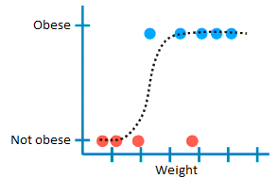
As we know, in logistic regression, we transform the y-axis from the probability of obesity to log(odds of obesity) … we can draw a candidate best fitting line on the graph … the only problem is that the transformation pushes the raw data to positive and negative infinity … and this means that the residuals are also equal to positive and negative infinity … so we CAN´T USE LEAST SQUARES to find the best fitting line.
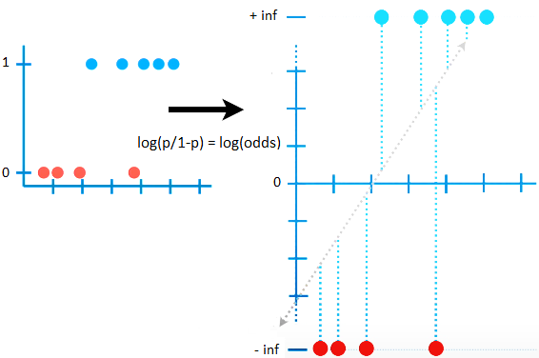
Instead, we use maximum likelihood … the first thing we do is project the original data points onto the candidate line … this gives each sample a candidate log(odds) value … then we transform the candidate log(odds) to candidate probabilities using the following formula:
$$\log\left(odds\right)=\log\left(\frac{p}{1-p}\right)$$
$$e^{\log\left(odds\right) }=\frac{p}{1-p}→p=\frac{e^{log⁡(odds)}}{1+e^{log⁡(odds)}}$$
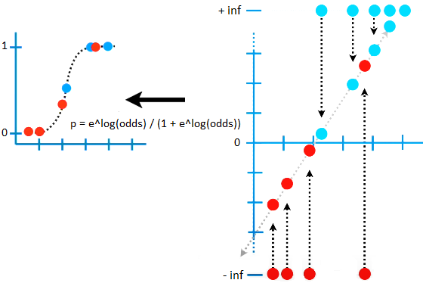
Now we use the observed status (obese or not obese) to calculate the likelihood for each data point given the shape of the candidate squiggly line:
- We´ll start by calculating the LIKELIHOOD OF THE OBESE MICE, given the shape of the squiggle … the likelihood that a particular mouse is obese, given the shape of this squiggle, is the value on the y-axis where that point intersects the squiggle … in other words, the likelihood that this mouse is obese, given the shape of the squiggle, is the same as the PREDICTED PROBABILTY (in this case, the probability is not calculated as the area under a curve, but instead is the y-axis value, and that is why it is the same as the likelihood) … the likelihood for all of the obese mice is just the product of the individual likelihoods.
- Now we´ll calculate the LIKELIHHOD OF THE MICE THAT ARE NOT OBESE, given the shape of the squiggle … the likelihood that a particular mouse is not obese is ONE MINUS THE PROBABILITY that mouse is obese … the likelihood for all of the mice that are not obese is just the product of the individual likelihoods.
The OVERALL LIKELIHOOD of the observed data, given the candidate squiggle is the product of all individual likelihoods:
$$L:likelihood$$
$$L given the squiggle=0,49×…×0,92×\left(1-0,9\right)×…×\left(1-0,01\right)$$
Statisticians prefer to use the log of $L$, because we add the logs of the individual likelihoods instead of multiplying them…
$$\log\left(L given the squiggle\right)=\log\left(0,49\right)+…+\log\left(0,92\right)+\log\left(1-0,9\right)+…+\log\left(1-0,01\right)$$
$$\log\left(L given the squiggle\right)=-3,77$$
… and this means that the log-likelihood of the original candidate line is -3,77.
Now we rotate the line … and calculate its log-likelihood by projecting the data onto it, transforming the log(odds) to probabilities, and then calculating the overall log-likelihood for the data given the squiggle … we get -4,15, so this new line is not as good as the first one.
Then we just keep rotating the log(odds) line and calculating its log-likelihood … ultimately, we´ll get a line that maximizes the likelihood (best fit for our data).

NOTE: The algorithm that finds the line with the max likelihood is pretty smart – each time it rotates the line, it does it in a way that increases the log-likelihood. Thus, the algorithm can find the optimal fit after a few rotations.
That´s all there is to it! But just like with linear regression there is more to logistic regression than just fitting a line. We want to know if that line represents a useful model, and that means we need an R-squared and a p-value … however, we have to do that without the usual residuals :/

